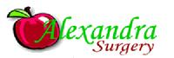
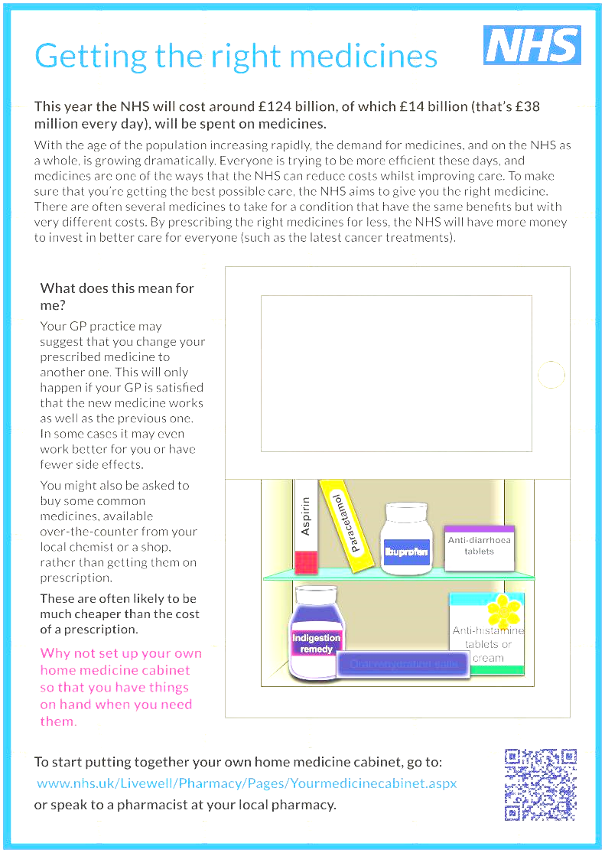
Over the counter medication

Alexandra Surgery and Haringey Medicines Management Team have agreed to limit prescribing of medication that can be purchased ‘over the counter’ (OTCs).

What are OTCs?
These are medication which can be bought from pharmacies or shops without a doctor’s prescription.
Common examples of OTCs are:
- Analgesics (painkillers) – paracetamol, ibuprofen
- Anti-diarrhoea medicine – loperamide
- Anti-fungal cream and nail paint
- Anti-histamines – cetirizine, chlorpheniramine, loratadine
- Nasal sprays for hay fever – beclomethasone
- Oral rehydration salts
The above list is for illustration and is not exhaustive.

What will happen now?
If we come across OTCs on repeat medication lists, we shall proceed to discontinue prescribing.

Your doctors are asking you to buy some OTCs over the counter, instead of getting them on prescription.

How can I manage?
You may, naturally, wish to discuss any issue with your doctor. Your doctor may suggest you change the prescribed medication to another one.

1 April 2018

